The Draft IRWM Plan is available in both Word and PDF versions. We encourage you to make your comments and suggested text edits directly in Word using the Comment and Track Changes tools in Word.
The following sentence has been edited using Track Changes to provide an example of what Track Changes looks like. When Track Changes is turned on, Word will automatically track any changes you make to the document.
In Word 2007 and 2010, both Comments and Track Changes can be accessed through the Review tab.
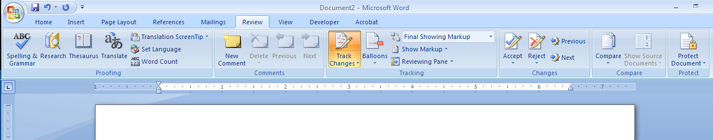
To insert a comment, highlight the text that you are commenting on, click New Comment, then enter your comment in the corresponding comment box that opens.
Track Changes should already be turned on in the version of the Word document that we posted to the website. However, if you find your changes are not being tracked, please turn on the Track Changes function by clicking the Track Changes button under the Review tab.

In Word 2003, Comments can be accessed through the Insert menu and Track Changes can be accessed through the Tools menu.

If you do not make your comments and edits directly in Word, please provide the section and page number that corresponds to each of your comments using the format below.
# | Commenter | Section | Page # | Comment
1
2
3
4

